

**Western Australian Certificate of Education**

**ATAR course examination, 2019**

**Question/Answer Booklet**

12 PHYSICS

Name

**Test 6 – Modern Physics**

|  |  |  |  |  |  |  |  |  |  |  |
| --- | --- | --- | --- | --- | --- | --- | --- | --- | --- | --- |
| Student Number: In figures |  |  |  |  |  |  |  |  |  |  |

**Mark: $\frac{}{\text{36}}$**  In words

#### Time allowed for this paper

Reading time before commencing work: five minutes

Working time for paper: fifty minutes

**Materials required/recommended for this paper**

To be provided by the supervisor

This Question/Answer Booklet

Formulae and Data Booklet

***To be provided by the candidate***

Standard items: pens, (blue/black preferred), pencils (including coloured), sharpener, correction fluid/tape, eraser, ruler, highlighters

Special items: non-programmable calculators satisfying the conditions set by the School Curriculum and Standards Authority for this course

**Important note to candidates**

No other items may be taken into the examination room. It is your responsibility to ensure that you do not have any unauthorised notes or other items of a non-personal nature in the examination room. If you have any unauthorised material with you, hand it to the supervisor before reading any further.

**Structure of this paper**

|  |  |  |  |  |  |
| --- | --- | --- | --- | --- | --- |
| Section | Number of questions available | Number of questions to be answered | Suggested working time  (minutes) | Marks available | Percentage of exam |
| Section One:  Short Answers | - | - | - | - | - |
| Section Two:  Problem-solving | 8 | 8 | 50 | 36 | 100 |
| Section Three:  Comprehension | - | - | - | - | - |
|  |  |  |  | **Total** | 100 |

**Instructions to candidates**

1. The rules for the conduct of examinations at Holy Cross College are detailed in the College Examination Policy*.* Sitting this examination implies that you agree to abide by these rules.

2. Write your answers in this Question/Answer Booklet.

3. Working or reasoning should be clearly shown when calculating or estimating answers.

4. You must be careful to confine your responses to the specific questions asked and to follow any instructions that are specific to a particular question.

5. Spare pages are included at the end of this booklet. They can be used for planning your

responses and/or as additional space if required to continue an answer.

• Planning: If you use the spare pages for planning, indicate this clearly at the top of the page.

• Continuing an answer: If you need to use the space to continue an answer, indicate in the original answer space where the answer is continued, i.e. give the page number. Fill in the number of the question(is) that you are continuing to answer at the top of the page.

6. Answers to questions involving calculations should be ***evaluated and given in decimal***

***form*.** It is suggested that you quote all answers to ***three significant figures***, with the

exception of questions for which estimates are required. Despite an incorrect final result, credit may be obtained for method and working, providing these are ***clearly and legibly set out***.

7. Questions containing the instruction "estimate" may give insufficient numerical data for their solution. Students should provide appropriate figures to enable an approximate solution to be obtained. Give final answers to a maximum of two significant figures and include appropriate units where applicable.

8. Note that when an answer is a vector quantity, it must be given with magnitude and direction.

9. In all calculations, units must be consistent throughout your working.

**Additional Data**

**Fundamental particles**

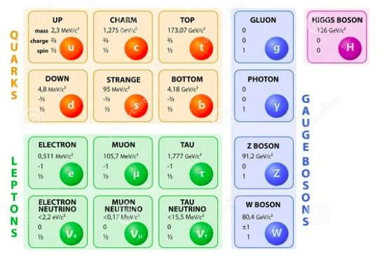

Table of common mesons

|  |  |  |
| --- | --- | --- |
|  |  |  |

|  |
| --- |
|  |
|  |
|  |

**Common Baryons**

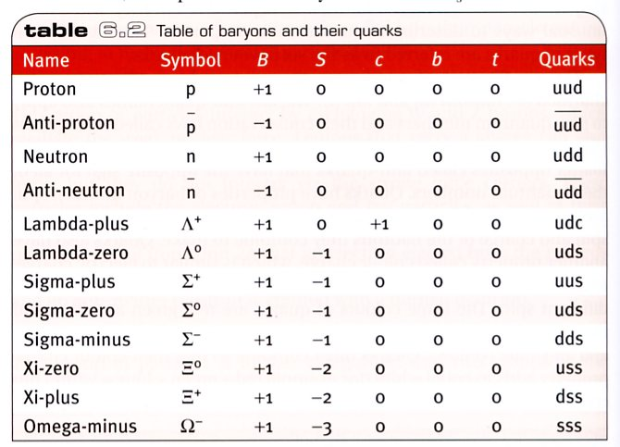

**Common Mesons**

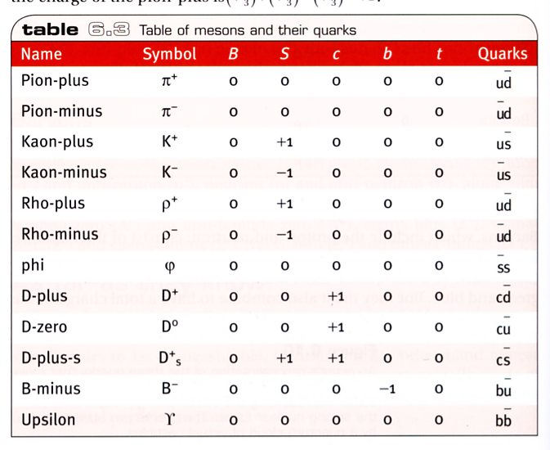

**Redshift and recessional velocity**



It can also be shown that:

where: z = redshift

Δλ = change in wavelength (moving source) (nm)

λ = wavelength of stationary source (nm)

v = recessional speed of galaxy (ms-1)

c0 = speed of light in a vacuum (ms-1)

**Hubble’s Law**



where vgalaxy = recessional speed of galaxy (kms-1)

d = distance to galaxy (Mpc)

Ho = Hubble’s constant (kms-1Mpc-1)

1.00 pc = 3.26 light years

1. (a)     One of the two postulates of Einstein’s theory of special relativity is that the speed of light is the same in any reference frame. Use the following example to show that this is correct.

A spaceship moving at 0.500*c* towards Earth fires a laser beam forwards at 1.00*c* relative to the ship. What is the speed of the laser measured from the Earth? (3 marks)

(b)     State and explain the other postulate. (2 marks)

2. A stationary pion - has a rest mass of 2.49 x 10-28 kg and a half-life of 2.60 x 10-8 s.

(a) Calculate the momentum of a pion - travelling at 0.985c relative to an observer in a laboratory. (3 marks)

(b) Determine the distance, in a laboratory frame of reference, travelled by the pion in one half-life. (4 marks)

3. In a particle beam experiment, a short pulse of 1.00 ns duration of particles moving at constant speed passed directly between two detectors at a fixed distance apart of

2.40 x 102 m. The pulse took 0.840 μs to travel from one detector to the other.

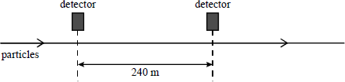

(a)      Calculate the speed of the particles. (2 marks)

(b)     Calculate the distance between the two detectors in the frame of reference of the particles. (3 marks)

4. In a 'thought experiment' about relativity, a student stated that a twin who travelled from the Earth to a distant planet and back at a speed close to the speed of light would be the same age on return as the twin who stayed on Earth. Explain why this statement is ***not*** correct.

(3 marks)

5. A proton is accelerated to a speed of 1.75 x 108 ms-1 by a high voltage in a linear accelerator. Determine the total energy of the particle at this speed. (3 marks)

6 A spaceship is approaching the Earth at 0.500*c* and shoots a canister away from the Earth at 0.650*c* relative to the Earth. What does an observer on the spaceship measure as the speed of the canister? (3 marks)

7. This table may be useful in answering the questions which follow.

|  |  |  |  |
| --- | --- | --- | --- |
| **particle** | **baryon number** | **lepton number** | **strangeness** |
| *π*− | 0 | 0 | 0 |
| p | 1 | 0 | 0 |
| p̄ | −1 | 0 | 0 |
| e− | 0 | 1 | 0 |
| e+ | 0 | −1 | 0 |
| *v̄*e | 0 | −1 | 0 |

The particle X, which is a strange particle, decays in the following way:

X → *π*− + p

(a)     State whether X is a meson, a baryon or a lepton. (1 mark)

(b)     Use conservation laws (baryon number, lepton number and charge) to decide whether the following decay of the *π*− is possible. Give a reason for your answer, showing some working. (2 marks)

*π*− → e+ + *ν*e

Is this decay possible?

Reason

(c) What is the difference between a baryon and a meson in terms of their structure?

(2 marks)

8. The following Feynman diagram shows a proton decaying to form a neutron, releasing a positron and electron neutrino.

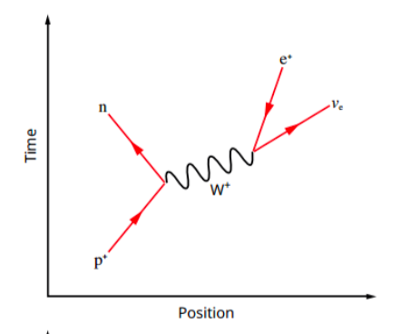

The equation for the process is:

p+ → n + e+ + νe

(a) What is W+ and what is its role in the process? (2 marks)

(c) Is this reaction possible? Show working to support your answer. (3 marks)